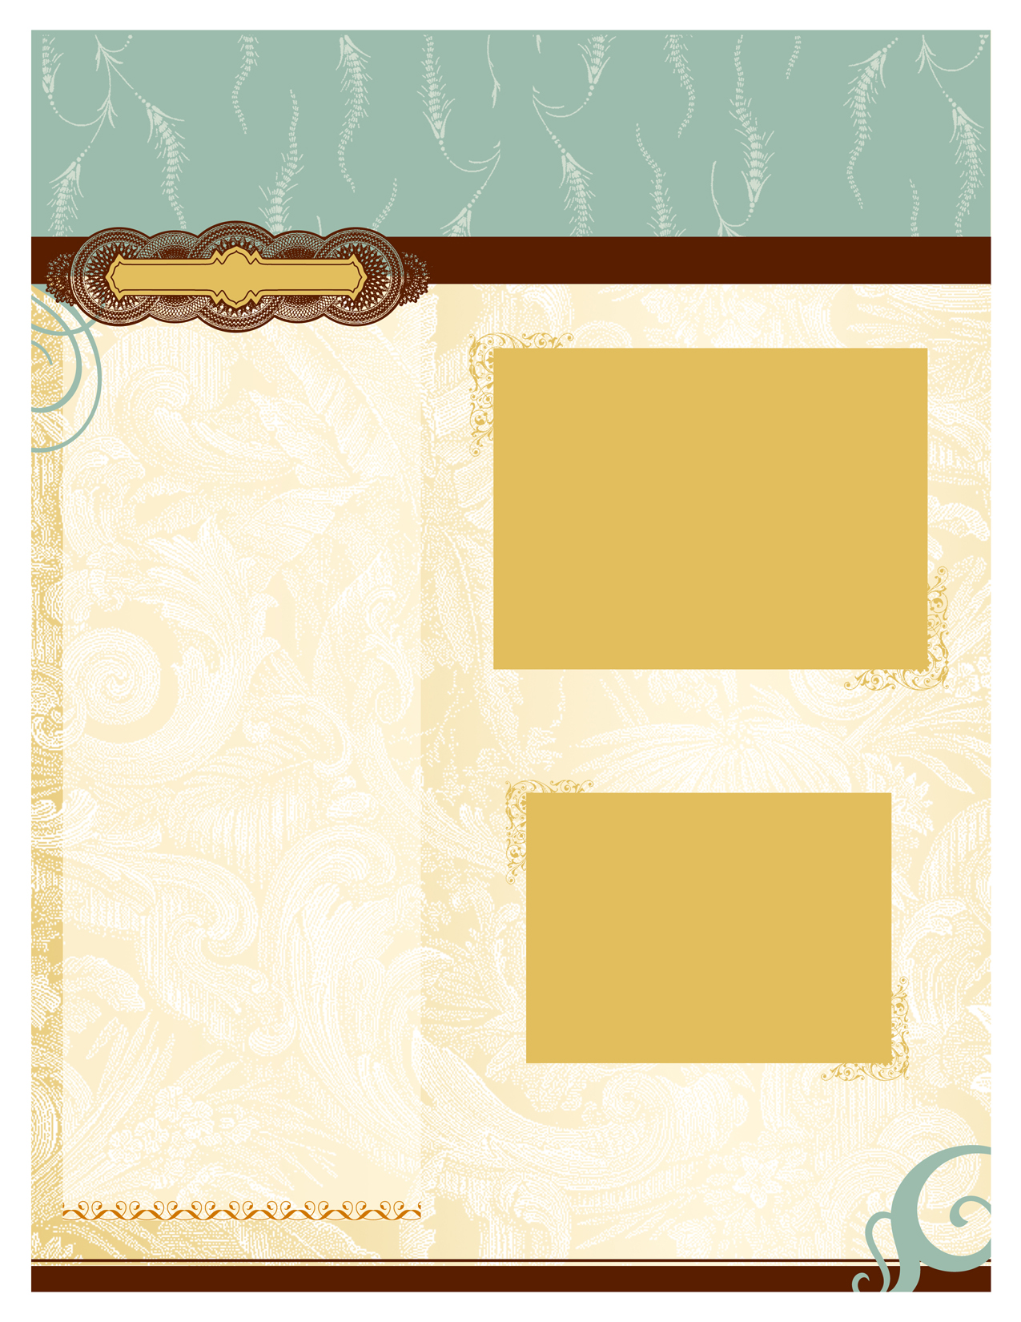

Exclusive Discount for Wedding Professionals

Bridal Beauty Associates

PREFERRED PRICING
Our company offers a wide selection of on-location bridal beauty services, including hair, makeup, massage, facials, nails, and men’s services.

Bridal Beauty Associates
www.bridalbeautytogo.com
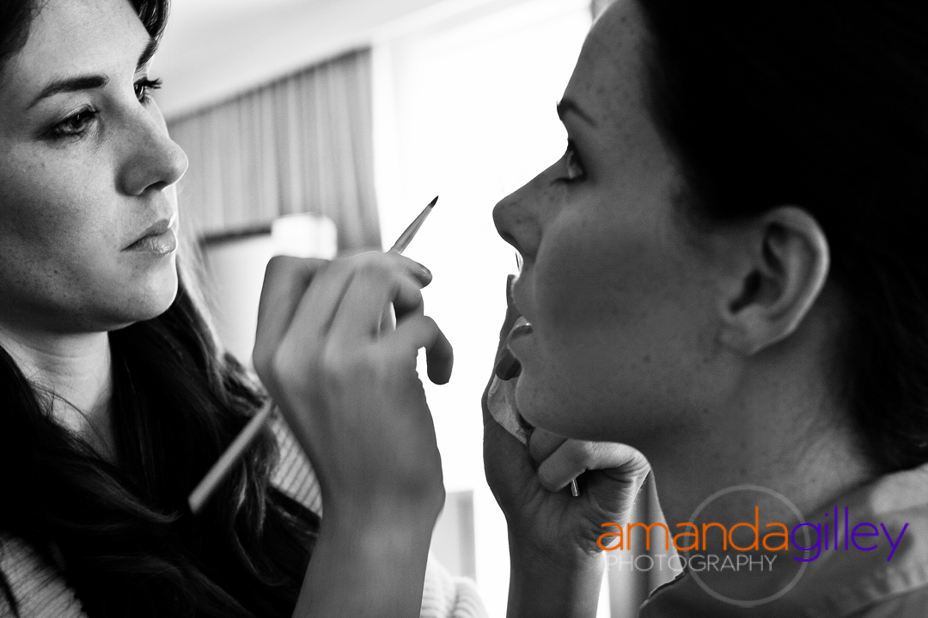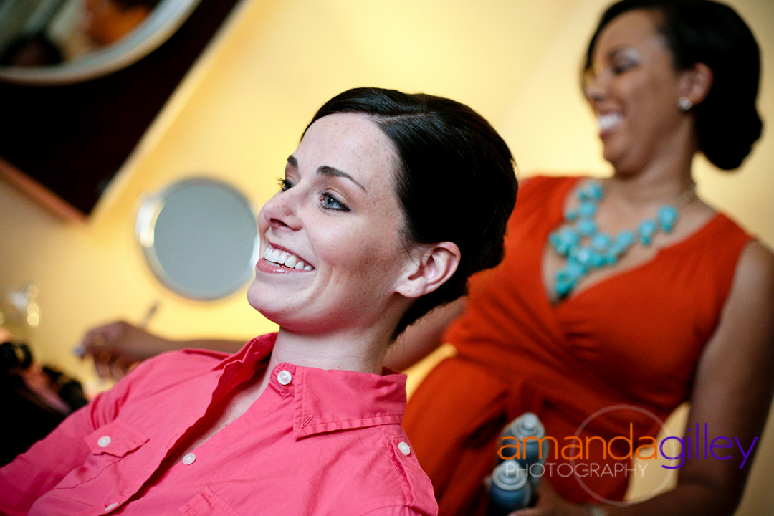
Bridal Beauty Associates is committed to improving our vendor relations in addition to providing the highest quality in beauty services and professionalism to our bridal clientele. We are happy to offer exclusive discounts to those brides referred to us by our wide network of vendors in the MD/DC/VA area. Our team of professional stylists are available to bring the spa experience to your clients in the comfort of their own home or hotel room. Below is the current pricing for our referrals:

Bride’s hair and makeup package (includes both hair and makeup trials along with wedding day services, airbrushing, and false lashes): $350, normally $390, valued at $440 if purchased a la carte
Bridal Party hair and makeup package: $155 per person (Mothers add $5), normally $175, valued at $185 if purchased a la carte
All hair and makeup packages also include Deluxe Swag Bags with touch up items for hair and makeup, and a full can of hairspray for the group.

Simply let your clients know to list your name at the time of inquiry to receive our preferred pricing.

Telephone 443-841-4808 (Krystal Morant-Owner/Lead Hairstylist)

Email Suzanne@BridalBeautyToGo.com (Owner/Office Manager)

10503 Golden Autumn Ct, Manassas, VA 20112

